Tour name: 6-Day Ultimate Journey Across Turkmenistan: From Marble Cities to Wild Canyons
Tour description: This 6-day journey reveals the many faces of Turkmenistan through a remarkable combination of monumental capital city landmarks, UNESCO heritage, desert adventure, sacred pilgrimage sites, and dramatic western landscapes. From the white-marble avenues of Ashgabat to the glowing Darvaza Gas Crater, from the ancient legacy of Merv to the spectacular cliffs of Yangykala Canyons, this itinerary is designed for travelers seeking both cultural depth and unforgettable scenery.
Starts at: Ashgabat Airport
Ends at: Ashgabat Airport
Please note: The starting and ending points of the itinerary may be adjusted depending on the client’s request, logistics, and tour format.
Group size: 3+
Days: 6
Price: From 1055 USD per person
Pricing note: The tour price depends on the number of participants. The more people join the tour, the lower the price per person will be.
Tour itinerary:
Day 1 | Arrival in Ashgabat: The White-Marble Capital  Arrival at Ashgabat International Airport, where you will be met by your guide and transferred to the city.  Begin your journey in Ashgabat, the capital of Turkmenistan, renowned for its monumental architecture, elegant urban layout, broad avenues, and striking white-marble buildings. Your first visits include the Independence Monument, one of the most important national landmarks of the country, and the Neutrality Monument, one of the defining symbols of modern Ashgabat.  Continue to the Alem Cultural and Entertainment Center to see the famous indoor Ferris wheel, an impressive reflection of the city’s modern architectural vision. You will also visit the Memorial Complex, dedicated to key moments of national history and remembrance.  In the evening, enjoy a panoramic night tour of Ashgabat, when the city takes on a particularly impressive atmosphere through its illuminated monuments, marble facades, and wide ceremonial boulevards.  Overnight at a hotel in Ashgabat.  Distance of the day: approx. 30–50 km
Day 2 | Ashgabat – Old Nisa – Akhal-Teke Horses – Ruhy Mosque – Darvaza  After breakfast, continue exploring the cultural and historical highlights of Ashgabat and its surroundings.  Begin with a visit to the National Museum of Turkmenistan, which offers an excellent introduction to the country’s archaeology, history, and cultural traditions. Then continue to Old Nisa, a UNESCO World Heritage Site and one of the most significant archaeological monuments in Central Asia. Once a royal residence of the Parthian Empire, Old Nisa remains one of Turkmenistan’s most valuable ancient treasures.  The tour continues with a visit to the Akhal-Teke horse stables, where you will encounter one of the country’s greatest national symbols. Known for their elegance, endurance, intelligence, and distinctive metallic sheen, Akhal-Teke horses are regarded as one of the oldest and finest horse breeds in the world.  Next, visit the grand Turkmenbashi Ruhy Mosque in Gypjak, one of the largest mosques in Central Asia and an important spiritual landmark of modern Turkmenistan.  After lunch, depart Ashgabat and drive north through the Karakum Desert toward Darvaza. By evening, arrive at the world-famous Darvaza Gas Crater, often referred to as the “Door to Hell.” The glowing crater in the middle of the desert creates one of the most unforgettable natural scenes in the region.  Enjoy a barbecue dinner near the crater and spend the evening under the open desert sky.  Overnight in tents or yurt-style desert camp near Darvaza.  Distance of the day: approx. 300 km
Day 3 | Darvaza – Ashgabat  Wake up to the peaceful atmosphere of the Karakum Desert and enjoy the unique morning scenery around the crater. After breakfast at the camp, depart for the return drive to Ashgabat.  Upon arrival in the capital, enjoy lunch at a local restaurant. In the afternoon, continue with a lighter city program and spend some time at Lenin Park, one of Ashgabat’s green public spaces, offering a pleasant contrast to the city’s monumental architecture.  Later, visit the elegant Ertugrul Gazi Mosque, notable for its Ottoman-inspired design and refined architectural lines. The rest of the evening may be spent at leisure or with an optional walk through the illuminated city center.  Overnight at a hotel in Ashgabat.  Distance of the day: approx. 280 km
Day 4 | Ashgabat – Mary – Ancient Merv – Ashgabat  After an early breakfast, depart for the historic region of Mary, one of the great gateways to the Silk Road heritage of Turkmenistan.  Today’s highlight is the archaeological park of Ancient Merv, a UNESCO World Heritage Site and one of the oldest and most important oasis cities of Central Asia. For centuries, Merv was a major center of trade, scholarship, and political power.  During the excursion, explore the most important monuments of the site, including the Great Kyz Kala and Little Kyz Kala, famous for their distinctive corrugated walls; the Mausoleum of Sultan Sanjar, one of the finest surviving monuments of Seljuk architecture; and the Mausoleum of Yusuf Hamadani, an important spiritual and pilgrimage site. The broader archaeological landscape offers a fascinating impression of the scale and significance of this once-powerful city.  After the excursion, return to Ashgabat.  Overnight at a hotel in Ashgabat.  Distance of the day: approx. 700–740 km
Day 5 | Ashgabat – Yangykala Canyons – Gozli Ata  After breakfast, depart Ashgabat and begin the journey west across Turkmenistan’s vast and changing landscapes.  By afternoon, arrive at the spectacular Yangykala Canyons, one of the most striking natural wonders of the country. Often described as the “Grand Canyon of Central Asia,” Yangykala is known for its dramatic cliffs and layered formations glowing in shades of red, pink, orange, and white. The panorama here is truly unforgettable and offers some of the most impressive scenery in Turkmenistan.  After time to explore the canyon viewpoints and enjoy the extraordinary landscape, continue toward Gozli Ata, one of the country’s most important sacred pilgrimage sites, set in a remote and atmospheric location.  Dinner and overnight stay in a yurt camp or simple local accommodation near Gozli Ata.  Distance of the day: approx. 560–600 km
Day 6 | Gozli Ata – Nohur – Kow Ata Underground Lake – Ashgabat Airport  After an early breakfast, begin the return journey toward Ashgabat through the western and southwestern landscapes of the country.  On the way, continue into the foothills of the Kopetdag Mountains to visit Nohur, a distinctive mountain village known for its preserved traditions, unique cultural identity, and beautiful natural surroundings. This region offers a very different impression of Turkmenistan, with quiet mountain scenery and a strong sense of local heritage.  Later, continue to Kow Ata Underground Lake, one of the country’s most unusual natural attractions. Hidden inside a cave, the lake is known for its warm, mineral-rich waters and its mysterious underground atmosphere. Those who wish may enjoy a swim before the final drive back to Ashgabat.  Upon arrival in the capital, transfer to Ashgabat International Airport for departure.  End of the tour.  Distance of the day: approx. 480–530 km

Tour Price includes:
• Meet and greet at Ashgabat International Airport with local English-speaking guide
• All transfers and transportation throughout the program
• Invitation letter for Turkmenistan visa support
• Accommodation in hotels in Ashgabat
• 1 night desert camp accommodation near Darvaza
• 1 night yurt camp or simple local accommodation near Gozli Ata
• 5 breakfasts
• 1 barbecue dinner at Darvaza
• Sightseeing tours and excursions as per itinerary
• Entrance fees to all sites mentioned in the program
• Visits to Independence Monument, Neutrality Monument, Alem Ferris Wheel, and Memorial Complex
• Visit to the National Museum of Turkmenistan
• Excursion to Old Nisa UNESCO World Heritage Site
• Visit to the Akhal-Teke horse stables
• Visit to Turkmenbashi Ruhy Mosque
• Visit to Ertugrul Gazi Mosque
• Excursion to Darvaza Gas Crater
• Excursion to Ancient Merv UNESCO World Heritage Site
• Visit to Kyz Kala monuments, Sultan Sanjar Mausoleum, and Yusuf Hamadani Mausoleum
• Excursion to Yangykala Canyons
• Visit to Gozli Ata pilgrimage site
• Excursion to Nohur village
• Visit to Kow Ata Underground Lake
• Bottled water during the tour
Tour Price NOT includes:
• International flights
• Lunches and dinners, except where specified in the program
• Turkmenistan tourist visa fee and migration charges
• Personal expenses
• Tips for guide and driver
• Optional activities not mentioned in the itinerary
• Hotel early check-in or late check-out, unless specified
• Charges for additional hotel services
• Travel insurance

Some photos from tour:
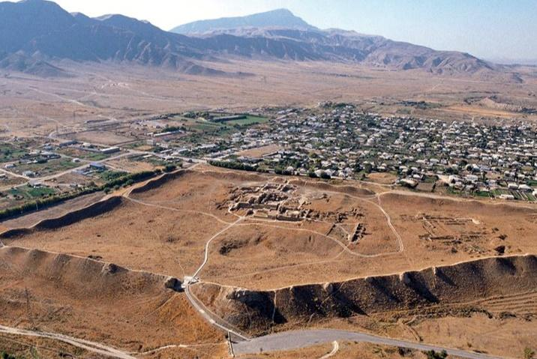
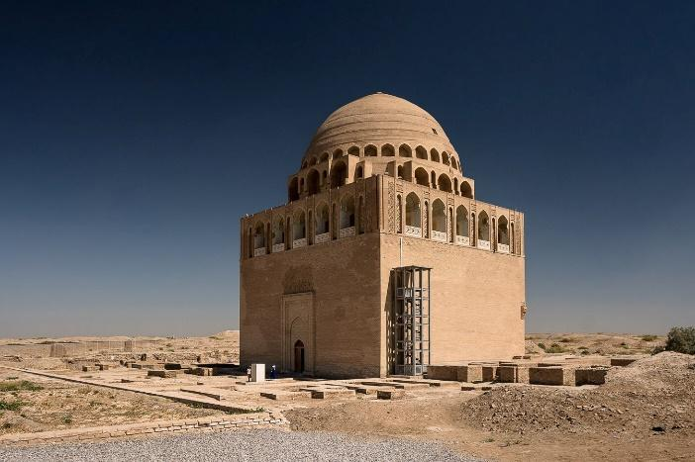
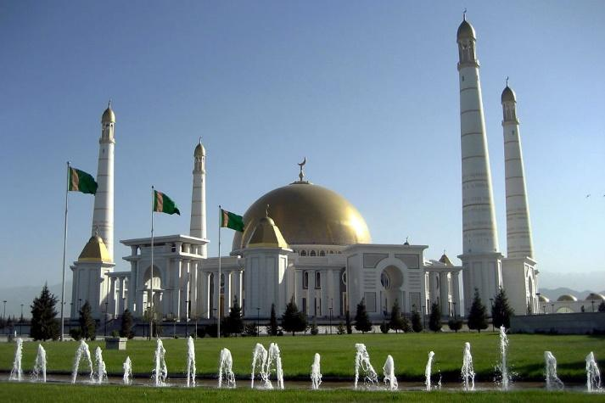

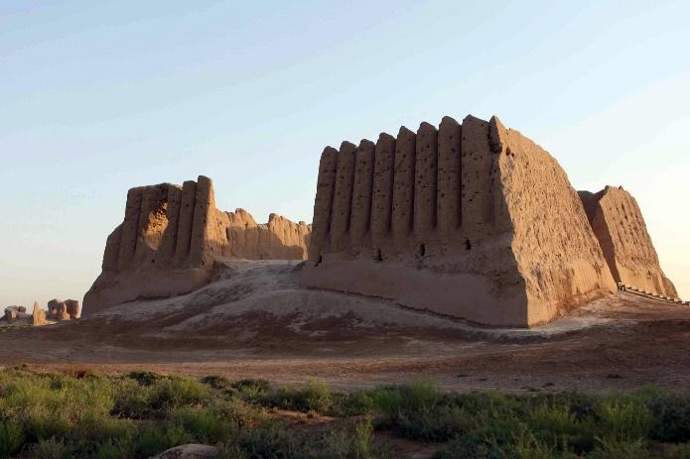

Notes
• The price is based on a minimum group size of 3 participants.
• The itinerary may be adjusted depending on flight schedules, weather conditions, and road conditions.
• The tour can also be organized starting from Ashgabat, Farap, or Shavat land border upon request.

